**M S Ramaiah Institute of Technology**

(An Autonomous Institute, Affiliated to VTU)

MSR nagar, MSRIT post, Bangalore-54

A Dissertation Report on

Intrusion Detection System

Submitted by

Abhilash Mukesh 1MS12CS001

Meeti Baliga 1MS12CS054

Raunak Shah 1MS12CS090

Rohit Sudhakar Shetty 1MS12CS091

*In partial fulfillment for the award of the degree of*

***Bachelor of Engineering in Computer Science & Engineering***



**DEPARTMENT OF COMPUTER SCIENCE & ENGINEERING**

**M.S.RAMAIAH INSTITUTE OF TECHNOLOGY**

**(Autonomous Institute, Affiliated to VTU)**

**BANGALORE-560054**

[www.msrit.edu](http://www.msrit.edu), **May 2015**

**Abstract**

Nowadays, the installation of affordable automation and security system for residential and office usage has been a necessity in line with the increasing number of break-in cases in urban city. The demand for the mentioned installation is going to increase rapidly in near future. The crux of providing such systems is the occupancy map of interested areas. The occupancy map will overlook the status of the protected areas. Hence, most of the security systems nowadays have the tendency of providing occupancy map of the designated areas. In most of the security systems, presence detectors are used to achieve a secured home or office. Passive infrared detector is widely used in the presence detector as a mean of human detection.

This project uses the application of pyroelectric infrared sensor (PIR) and light detecting module in handling sensor information so as to provide real time occupancy map on computer in control unit. PIR sensor is used to detect the presence of human in a protected room. Wireless communications network by using frequency modulation technique is developed to handle data transmission through the air. The personal computer plays a significant role in providing the intelligent centralized controls of the entire system. A software package has been developed for visual display, control mechanism configuration, and embedded server-client application*.*

**Contents**

***Declaration i***

***Acknowledgements ii***

***Abstract iii***

***List of Figures***

***List of Tables***

1 **INTRODUCTION**

* 1. General Introduction…………………………………… 1
  2. Statement of the Problem………………………………. 1
  3. Objectives of the project…………… ………………….. 1
  4. Project deliverables…………………………………….. 1
  5. Current Scope…………………………………………... 1
  6. Future Scope……………………………………………. 2

1. **PROJECT ORGANIZATION**
   1. Software Process Models………………………………. 3
   2. Roles and Responsibilities ……………………………... 3
2. **LITERATURE SURVEY**

3.1 Introduction…………………………………………….. 4

3.2 Main Body……………………………………………… 4

3.3 Conclusion of Survey…………………………………... 4

1. **SOFTWARE REQUIREMENT SPECIFICATIONS**

4.1 Product Overview………………………………………….. 5

4.2 External Interface Requirements…………………………… 5

4.2.1 User Interfaces

4.2.2 Hardware Interfaces

4.2.3 Software Interfaces

4.2.4 Communication Interfaces

4.3 Functional Requirements ………………………………….. 5

4.3.1 Functional Requirement 1.1

4.3.2 Functional Requirement 1.n

4.4 Software System Attributes ………………………………... 6

4.4.1 Reliability

4.4.2 Availability

4.4.3 Security

4.4.4 Portability

4.4.5 Maintainability

4.4.6 Performance

4.5 Performance Requirements ……………………………….... 6

4.6 Database Requirement

4.7 Design Constraints

4.8 Other Requirements

1. **DESIGN**
   1. Introduction ………………………………………………. 7
   2. Architecture Design……………………………………….. 8
   3. Graphical User Interface ………………………………….. 9
   4. Sequence Diagram………………………………………… 10
   5. Data flow diagram……………………………………….... 11
   6. Metric calculation ……………………………………….... 12
2. **IMPLEMENTATION**
   1. Tools Introduction ……………………………………….. 13
   2. Technology Introduction………………………………..... 14
   3. Overall view of the project in terms of implementation…..16
   4. Explanation of Algorithm and how it is been implemented.17
   5. Information about the implementation of Modules………. 17
3. **TESTING**

**7.1** Results and Snapshots ……………………………………. 18

1. **CONCLUSION & SCOPE FOR FUTURE WORK**
2. **REFERENCES**

**INTRODUCTION**

**1.1 GENERAL INTRODUCTION**

Wireless sensor network is a very useful system for monitoring and interacting with environment because it consists of small senor nodes with wireless communication capability which enables easy integration with environment. Moreover, they can be automated so no human intervention is required. There are a lot of monitoring applications based on wireless sensor network technology and they are interested in monitoring specific events or objects.

**1.2 STATEMENT OF THE PROBLEM**

The project aims at creating a portable and efficient intrusion detector that notifies the user of any human interference around the sensor’s field of view. The goal of the project is to increase sense of security in homes, office, or factory environment that require are prone to thefts.

**1.3 OBJECTIVES OF THE PROJECT**

* To use the application of pyroelectric infrared sensor (PIR) and light detecting module in handling sensor information so as to provide real time occupancy .
* To store sensor data to Google forms and sending an email to the corresponding authorities.

**1.4 PROJECT DELIVERABLES**

* An Intrusion Detection System that uses the application of pyroelectric infrared sensor (PIR) and light detecting module in handling sensor information so as to provide real time occupancy map on computer in control unit
* A database with sensor information systematically represented using Google forms.
* E-mail facility to notify the corresponding user about the intrusion.

**1.5 CURRENT SCOPE**

Not only they need to figure out the occurrence or existence of such events or objects, but also they need to find out where the events have occurred or the objects are present. We using the light detecting module for this purpose. Examples of this kind of application include fire monitoring systems, surveillance systems, livestock monitoring and protection systems, and so on.

The target application aimed by this project is surveillance systems for home, office, or factory. In surveillance systems, it is very important to detect undesired intrusion by foreign people while nobody is present in office, home, or factory. Wireless sensor network is ideal for such application because it is a fully automated system which does not require any human intervention and easily connected to external network such as the Internet or the cellular network so it can notify the user about the undesired situation via email.

**1.6 FUTURE SCOPE**

The Raspberry Pi can be connected to a camera module that can be used to take high-definition video, as well as stills photographs. It has plenty to offer advanced users. It can be used for time-lapse, slow-motion and other video cleverness. You can also use the libraries bundled with the camera to create effects.Hence the camera can be sued to enhance this INTRUSION DETECTION SYSTEM in future.

**PROJECT ORGANIZATION**

* 1. **SOFTWARE PROCESS MODELS**

The Software model we are using is Iterative model. An iterative [life cycle model](http://istqbexamcertification.com/what-are-the-software-development-models/) does not attempt to start with a full specification of requirements. Instead, development begins by specifying and implementing just part of the software, which can then be reviewed in order to identify further requirements. This process is then repeated, producing a new version of the software for each cycle of the model.

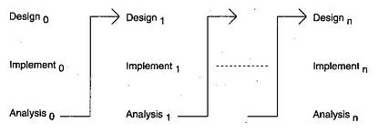

In the diagram above when we work **iteratively**we create rough product or product piece in one iteration, then review it and improve it in next iteration and so on until it’s finished. As shown in the image above, in the first iteration the whole painting is sketched roughly, then in the second iteration colors are filled and in the third iteration finishing is done. Hence, in iterative model the whole product is developed step by step.

Thus we use this Tool in order to implement out project because we iterated through our project, found out new responsibility which has to be added and implemented those features. Had our Guide to evaluate our project continuously and hade to make changes according to that. Thus we implemented this model

**Advantages of Iterative model:**

* In iterative model we can only create a high-level design of the application before we actually begin to build the product and define the design solution for the entire product. Later on we can design and built a skeleton version of that, and then evolved the design based on what had been built.
* In iterative model we are building and improving the product step by step. Hence we can track the defects at early stages. This avoids the downward flow of the defects.
* In iterative model we can get the reliable user feedback. When presenting sketches and blueprints of the product to users for their feedback, we are effectively asking them to imagine how the product will work.
* In iterative model less time is spent on documenting and more time is given for designing.
  1. **ROLES AND RESPONSIBILITIES**

This project was done in a group of four, and each of us was given tasks to perform and then integrated the whole project in order to make it one. Our project is about intrusion detection System Which basically detects and handles the data on the cloud.

One of the person in the group was given the responsibility to collect all the hardware required for the project, and the other person had to get in information of the project and the connection that have to made, the other person was given the task to place the data on the cloud and compute the data and the last person was given the role of sending the email.

**LITERATURE SURVEY**

**3.1 INTRODUCTION**

In this highly developing era, where directly or indirectly, everything is dependent on computation and information technology, Raspberry Pi proves to be a smart, economic and efficient platform for implementing the home automation. Also, in Web server based home automation, the design of web server and the space required is eliminated by this method, because it simply uses the already existing web server provided by G-mail.

**3.2 MAIN BODY**

A simple approach determining direction to the position of human was proposed by A. S. Sekmen for human-robot interaction. In A.S. Sekmen’s research, PIR sensors are

attached to a robot and used to find out relative direction of human from the current position of robot. Several PIR sensors were attached together making a circle and the relative direction of human is the position of PIR sensor which detects the human. The advantages of PIR sensors were also discussed.

Moreover, the intensity-based localization scheme is proposed by M. Waelchli.[5] It has been shown that event localization based on signal intensities gathered by sensor nodes is mathematically possible and the actual implementation and proof of applicability are discussed in later publication. In addition, a fully distributed object tracking framework, DELTA was also introduced by M. Waelchli. This framework tracks and localizes light using photo sensors. DELTA maintains groups of nodes that are dynamically formed and a group leader is elected by a measurement-based election algorithm. The group leaser is in charge of group maintenance, data gathering and processing, as well as reporting to the base station.

**3.3CONCLUSION**

Human tracking method proposed in this Project uses PIR (Passive infrared) sensors. PIR sensors detect changes in infrared radiation which is caused by movement of a person (or object) which has different temperature from the surroundings. Because PIR sensors detect temperature differences, it is ideal for detecting the motion of people by detecting the difference of their body temperature and the surroundings. In addition, PIR sensor used in the experiment of the method proposed in this paper has wide sensing area of 10m with about 90°. Therefore, we have decided to use PIR sensors with region-based tracking algorithm for detecting human movement.

**SOFTWARE REQUIREMENT SPECIFICATIONS**

**4.1 PRODUCT OVERVIEW**

Raspberry pi is a credit- card sized computer. It functions almost as a computer. There are various sensors used such as Passive Infrared Sensor, Light module. In these types of surveillance systems, the person who is stationary and is located in that particular area can only view what is happening in that place .Whereas here, even if the user is moving from one place to another ,he/she can keep track of what is happening in that particular place. Also another advantage is that it offers privacy on both sides since it is being viewed by only one person .The other major advantage is that it is a simple circuit .the operating system used here is Raspbian OS. Raspbian OS has to be installed so that the image can be transmitted to the smartphone.

**4.2 EXTERNAL INTERFACE REQUIREMENTS**

**4.2.1 User Interfaces**

A web application is created to communicate details of the intrusion and light intensity of the environment to the user. The web application is updated every few minutes for a better user experience.

**4.2.2 Hardware Interfaces**

Raspberry pi Model-2 with Raspbian OS installed, acts as the hardware interface along with the passive infrared motion sensor and the photo resistor module

**4.2.3 Software Interfaces**

The software is executed by running the python program on the terminal of the Raspberry pi. Raspbian Operating System runs on the raspberry pi.

**4.2.4 Communication Interfaces**

The PIR communicates with the raspberry pi on intrusion detection. The raspberry pi via the internet saves the details of intrusion into a Google form.

**4.3 FUNCTIONAL REQUIREMENTS**

The project must be capable of performing the following tasks:

* Detect intrusion from its surroundings
* Detect change in light intensity
* Process received raw data
* Save data into Google forms
* Retrieve data from Google forms and save to database
* Receive data from database and display it on the web application.

**4.4 SOFTWARE SYSTEM ATTRIBUTES**

**4.4.1Reliability**

The application’s reliability depends on the internet connections and the well-being of the server. It also depends on the performance of the sensors. Due to its simple design the project can be considered fairly reliable.

**4.4.2Availability**

The service is available all time.

**4.4.3 Security**

Server crashes are the biggest security threat. Since google forms are used unwanted intrusion can be of concern.

**4.4.4 Portability**

The software is fairly portable. The hardware can be installed anywhere and data can be accessed from any part of the world.

**4.4.5 Maintainability**

The hardware has minimum maintenance requirements as it does not have a complex design. However a database has to be maintained and checked for sufficient space regularly.

**4.4.6 Performance**

The performance directly depends on the sensors used for the project. Their performance can be highly increased by increasing their sensitivity.

**4.5 PERFORMANCE REQUIREMENTS**

* The Raspberry pi should have continuous power supply.
* The database should be regularly updated without lag.
* The sensor should not be sensitive to minor intrusions which can lead to incorrect output.

**4.6 DATABASE REQUIREMENTS**

The project uses MongoDB database along with google forms to store data.JDBC is used to retrieve data from MongoDB and display on the web application.

**4.7 DESIGN CONSTRAINTS**

* The intrusion detector works only when the raspberry pi is supplied with continuous power
* Intrusion on the rarer side of the sensor cannot be detected.

**DESIGN**

**5.1 INTRODUCTION**

The architecture of the intrusion detector consists of the following components

* Raspberry Pi Model-2
* Passive infrared motion sensor
* Photo Resistor
* Light Detection module
* HDMI cable, USB cable and jumper wires, Ethernet cable

Raspberry pi Model-2:

The Raspberry Pi is a series of credit card sized single-board computers. Raspberry Pi is based on the Broadcom BCM2835 system on a chip (SoC), which includes an ARM1176JZF-S 700 MHz processor, Video Core IV GPU,and was originally shipped with 256 megabytes of RAM, later upgraded (models B and B+) to 512 MB. The system has Secure Digital (SD) (models A and B) or MicroSD (models A+ and B+) sockets for boot media and persistent storage.

Passive infrared motion sensor:

An electronic sensor that measures infrared (IR) light radiating from objects in its field of view. A PIR-based motion detector is used to sense movement of people, animals, or other objects moving around within approximately 10m from the sensor.

Photo sensitive resistor

A photo sensitive resistor or light-dependent resistor (LDR) or photocell is a light-controlled variable resistor. The resistance of a photo resistor decreases with increasing incident light intensity; in other words, it exhibits photoconductivity. A photo resistor can be applied in light-sensitive detector circuits, and light- and dark-activated switching circuits.

Light Detection module

Light Sensor module has a light sensor on board, and could be used to detect the light intensity. This module can be connected to Raspberry Pi using GPIO pins.

**5.2 ARCHITECTURE DESIGN**

Passive infrared sensor:

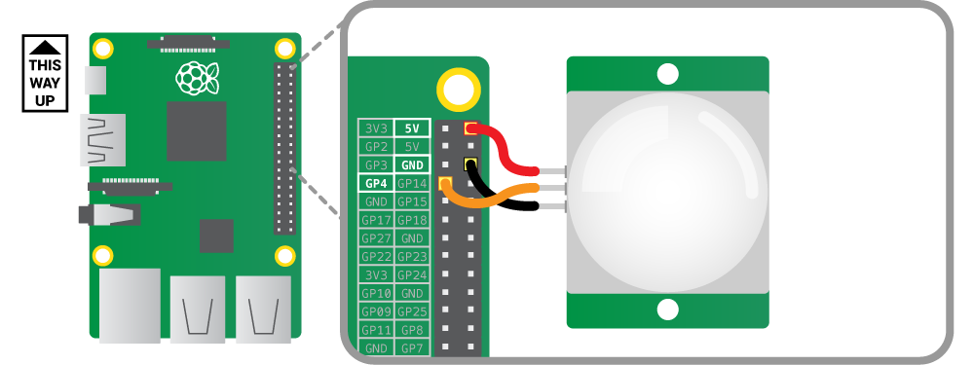

Photo Resistor:

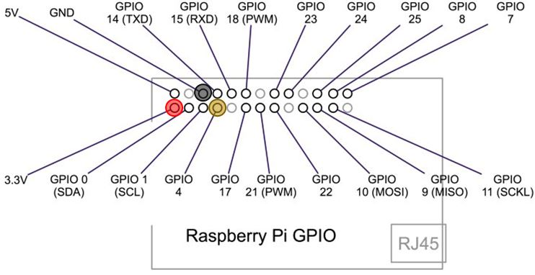

**5.3GRAPHICAL USER INTERFACE**



**MAIL**

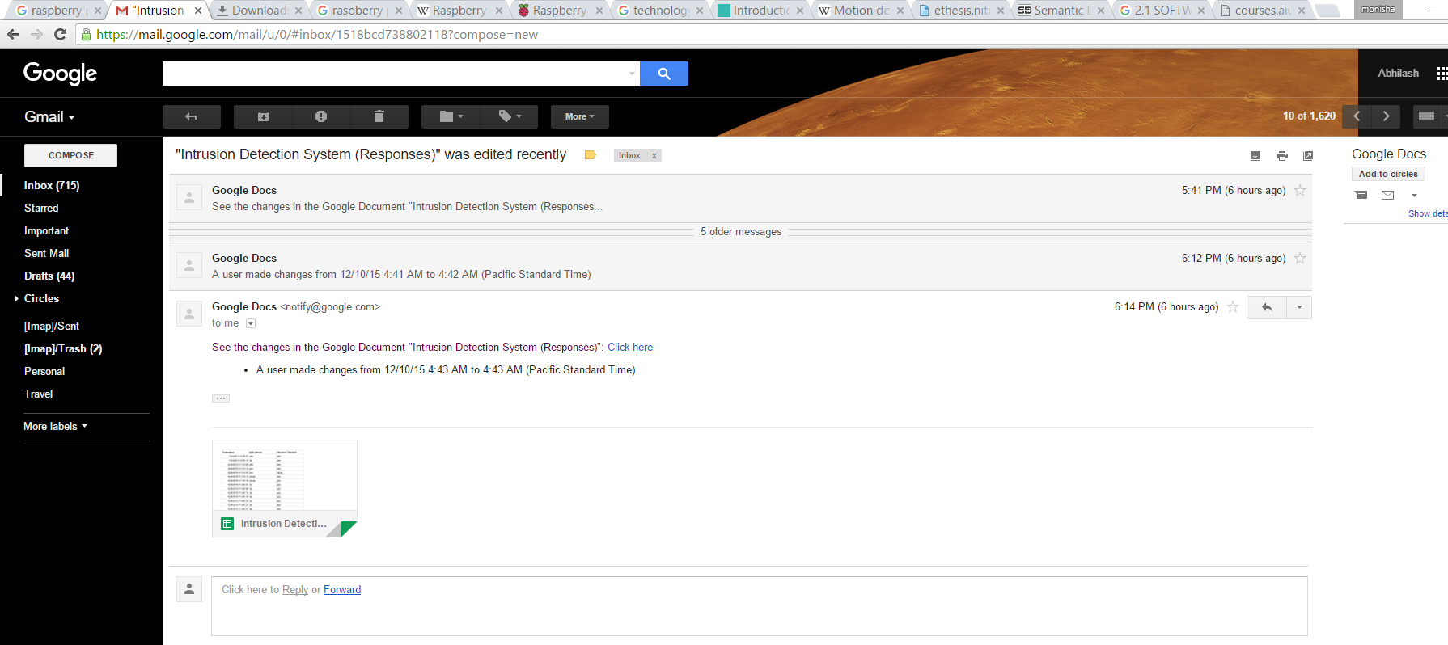

**5.4 SEQUENCE DIAGRAM**

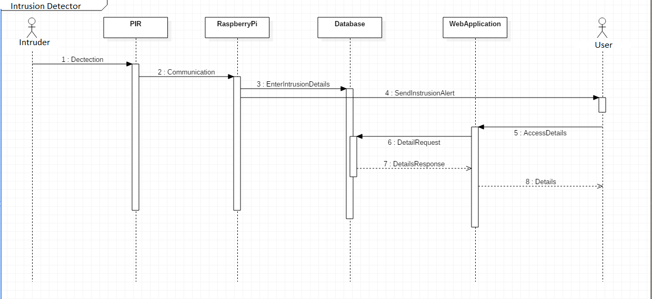

**5.5 DATA FLOW DIAGRAM**

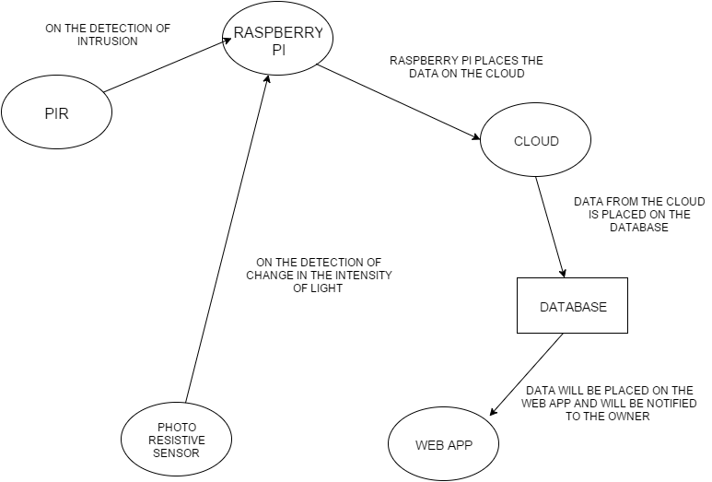

**IMPLEMENTATION**

**6.1 TOOLS INTRODUCTION**

Raspberry PI:

The Raspberry Pi is a series of credit card–sized single-board computers developed in the United Kingdom by the Raspberry Pi Foundation with the intention of promoting the teaching of basic computer science in schools and developing countries.[6][7][8] The original Raspberry Pi and Raspberry Pi 2 are manufactured in several board configurations through licensed manufacturing agreements with Newark element14 (Premier Farnell), RS Components and Egoman.[9] The hardware is the same across all manufacturers.

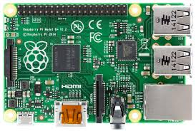

We have used a raspberry pi 2 model B, which has the following hardware specifications:

* Broadcom BCM2836 Arm7 Quad Core Processor powered Single Board Computer running at 900MHz
* 1GB RAM
* 40pin extended GPIO
* 4 x USB 2 ports
* 4 pole Stereo output and Composite video port
* Full size HDMI
* DSI display port for connecting the Raspberry Pi touch screen display
* Micro SD port for loading your operating system and storing data
* Micro USB power source up to 1.2 AMP

PIR Sensor Module

Infrared radiation enters through the front of the sensor, known as the 'sensor face'. At the core of a PIR sensor is a solid state sensor or set of sensors, made from pyroelectric materials—materials which generate energy when exposed to heat. Typically, the sensors are approximately 1/4 inch square (40 mm2), and take the form of a thin film. Materials commonly used in PIR sensors include gallium nitride (GaN), caesium nitrate (CsNO3), polyvinyl fluorides, derivatives of phenylpyridine, and cobalt phthalocyanine. The sensor is often manufactured as part of an integrated circuit.

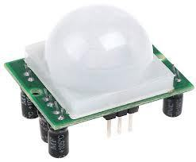

Fig 4

PIR sensor allow you to sense motion, usually to detect motion in or out of the sensor range.

* Output: Digital pulse high (3V) when triggered (motion detected) digital low when idle (no motion detected).
* Sensitivity range: up to 20 feet (6 meters) 110° x 70° detection range
* Power supply: 3V-9V input voltage, but 5V is ideal.

Light Detecting Module

The Grove - Light Sensor module incorporates a Light Dependent Resistor (LDR). Typically, the resistance of the LDR or Photo resistor will decrease when the ambient light intensity increases. This means that the output signal from this module will be HIGH in bright light, and LOW in the dark.

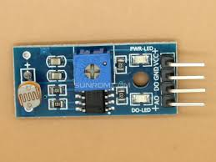

* Voltage: 3-5V
* Supply Current: 0.5-3mA
* Light resistance: 20KΩ
* Dark resistance: 1MΩ
* Response time: 20-30 secs
* Peak Wavelength: 540 nm

**6.2 TECHNOLOGY INTRODUCTION**

* **About Raspbian**

Raspbian is a free operating system based on Debian optimized for the Raspberry Pi hardware. An operating system is the set of basic programs and utilities that make your Raspberry Pi run. However, Raspbian provides more than a pure OS: it comes with over 35,000 packages, pre-compiled software bundled in a nice format for easy installation on your Raspberry Pi.

The initial build of over 35,000 Raspbian packages, optimized for best performance on the Raspberry Pi, was completed in June of 2012. However, Raspbian is still under active development with an emphasis on improving the stability and performance of as many Debian packages as possible.

Raspbian (recommended for Raspberry Pi 1)[90] – is maintained independently of the Foundation;[91] based on the Debian ARM hard-float (armhf) architecture port originally designed for ARMv7 and later processors (with Jazelle RCT/ThumbEE and VFPv3), compiled for the more limited ARMv6 instruction set of the Raspberry Pi 1. A minimum size of 4 GB SD card is required for the Raspbian images provided by the Raspberry Pi Foundation. There is a Pi Store for exchanging programs.[92][93]

The Raspbian Server Edition is a stripped version with fewer software packages bundled as compared to the usual desktop computer oriented Raspbian.[94][95]

The Wayland display server protocol enables efficient use of the GPU for hardware accelerated GUI drawing functions.[96] On 16 April 2014, a GUI shell for Weston called Maynard was released.

PiBang Linux – is derived from Raspbian.[97]

Raspbian for Robots – is a fork of Raspbian for robotics projects with Lego, Grove, and Arduino.

* **About Python**

Python is a widely used general-purpose, high-level programming language.[20][21] Its design philosophy emphasizes code readability, and its syntax allows programmers to express concepts in fewer lines of code than would be possible in languages such as C++ or Java. The language provides constructs intended to enable clear programs on both a small and large scale. Python supports multiple programming paradigms, including object-oriented, imperative and functional programming or procedural styles. It features a dynamic type system and automatic memory management and has a large and comprehensive standard library. Python interpreters are available for installation on many operating systems, allowing Python code execution on a wide variety of systems. Using third-party tools, such as Py2exe or Pyinstaller,[26] Python code can be packaged into stand-alone executable programs for some of the most popular operating systems, allowing the distribution of Python-based software for use on those environments without requiring the installation of a Python interpreter. Python, the reference implementation of Python, is free and open-source software and has a community-based development model, as do nearly all of its alternative implementations. Python is managed by the non-profit Python Software Foundation.

* **About google form**

Google Docs, Google Sheets and Google Slides are a word processor, a spreadsheet and a presentation program respectively, all part of a free, web-based software office suite offered by Google within its Google Drive service. The suite allows users to create and edit documents online while collaborating with other users in real-time.The three apps are available as web applications, as Chrome apps that work offline, and as mobile apps for Android and iOS. The apps are compatible with Microsoft Office file formats. The suite also consists of Google Forms (survey software), Google Drawings (diagramming software) and Google Fusion Tables (database manager; experimental). While Forms and Tables are only available as web applications, Drawings is also available as a Chrome app.The suite is tightly integrated with Google Drive.[2] All files created with the apps are by default saved to Google Drive.

**6.3 OVERALL VIEW OF THE PROJECT IN TERMS OF IMPLEMENTATION**

In this project we have designed and implement surveillance system by use of smart sensors like pyro electric infrared sensors (PIR) and Light Detecting Module (LDR) to detect an intruder in a house, ATM, Industries, Bank Locker room, storehouse or any other environment prone to thefts. The PIR sensors and the Light Detecting Module are placed on the ceiling, and the ultrasonic sensor module consisting of a transmitter and a receiver are placed vertically on the walls. We are then sending information like time, date, and the state of LDR when the intrusion has occurred to the authorized and related personnel via e-mail to avoid the storage cost. This system will also help to reduce the power consumption.

**6.4 EXPLANATION OF ALGORITHM AND HOW IT IS BEEN IMPLEMENTED**

importRPi.GPIO as GPIO

import time

fromurllib.request import urlopen

import sys

sensor = 4

GPIO.setmode(GPIO.BCM)

GPIO.setup(sensor, [GPIO.IN](http://GPIO.IN), GPIO.PUD_DOWN)

previous_state = False

current_state = False

while True:

time.sleep(0.001)

previous_state = current_state

current_state = GPIO.input(sensor)

ifcurrent_state != previous_state:

new_state = "HIGH" if current_state else "LOW"

ifnew_state== "HIGH":

localtime=time.asctime(time.localtime(time.time()))

print ("intrusion detected at local time",localtime)

urlopen("https://docs.google.com/forms/d/1OvMU9v4GYL6BMX_9V2JxwwiXgupvT2pR-HueGl-j2ZU/formResponse?ifq&entry.1963731240=yes&submit=Submit")

**TESTING**

**7.1 RESULTS AND SNAPSHOTS**

BOOTING

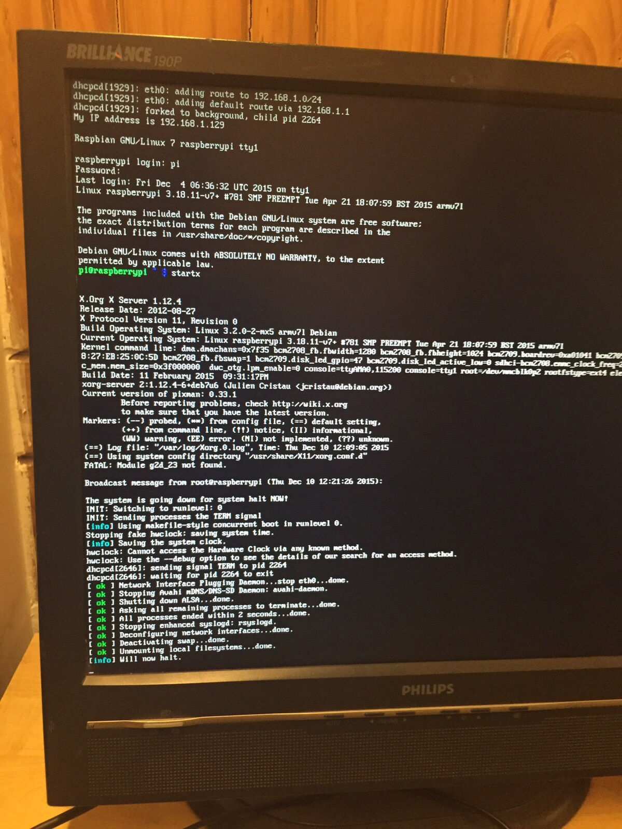

CODE

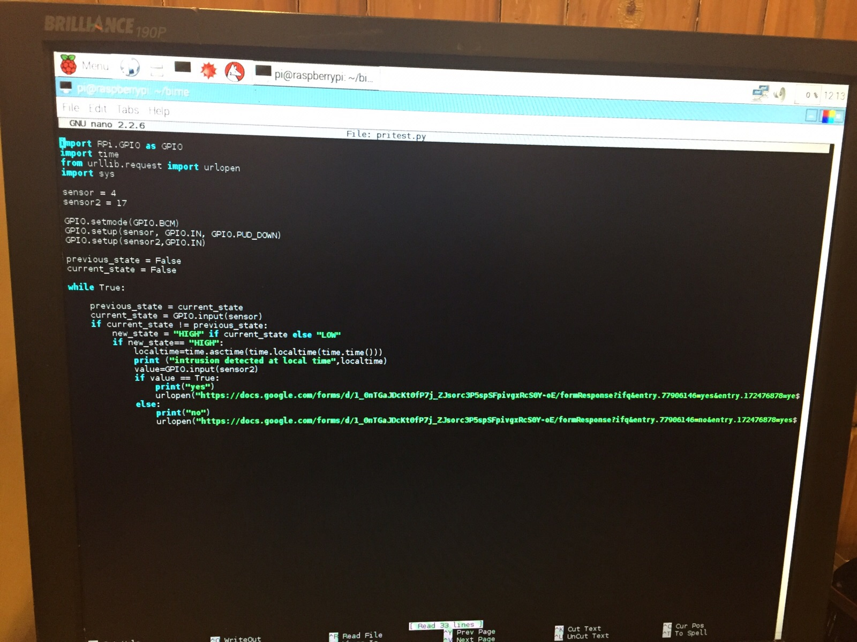

OUTPUT

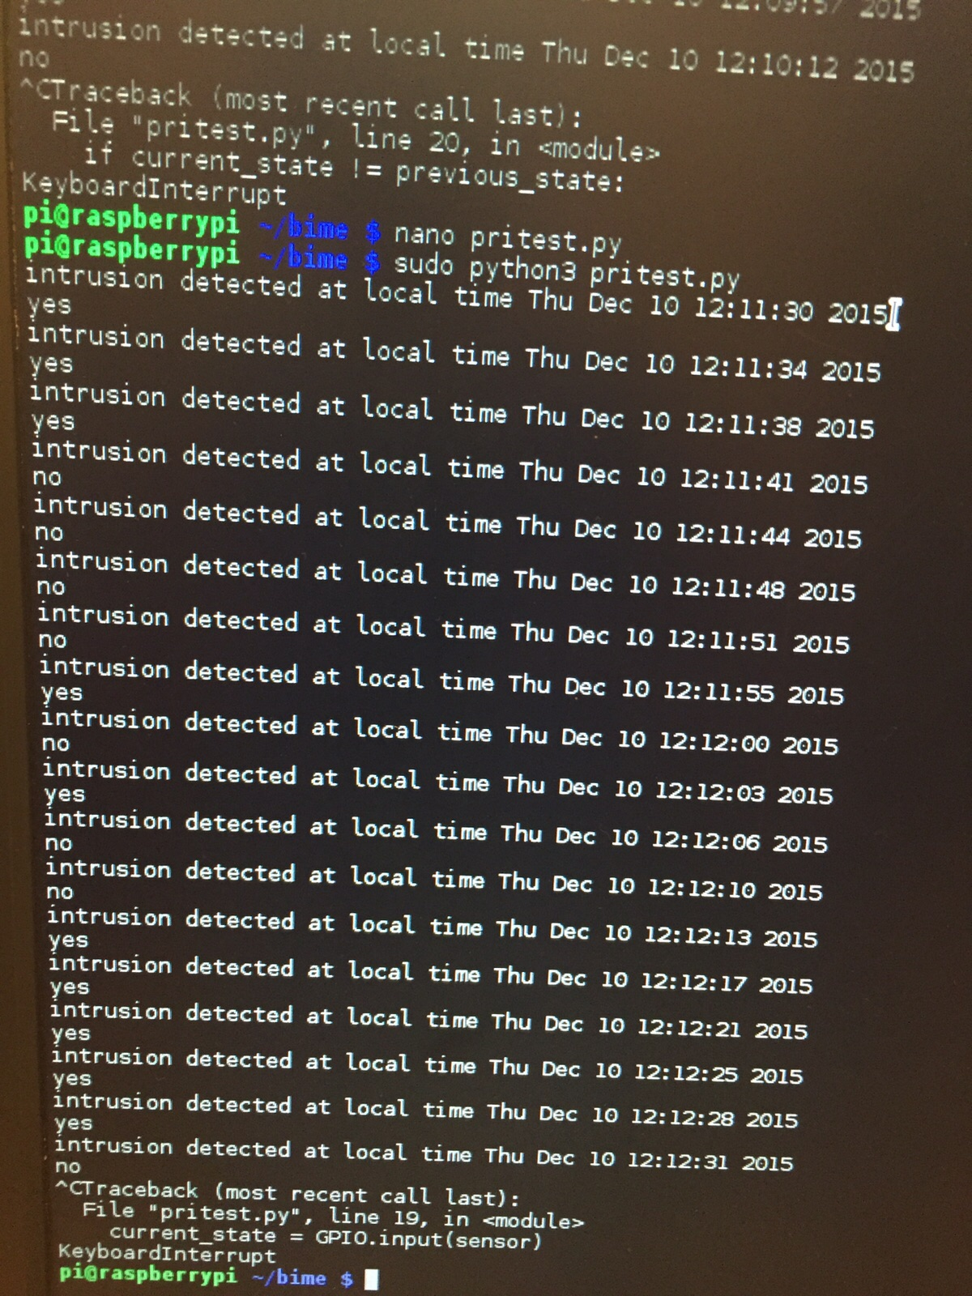

DATABASE



MAIL



**CONCLUSION & SCOPE FOR FUTURE WORK**

In this highly developing era, where directly or indirectly, everything is dependent on computation and information technology, Raspberry Pi proves to be a smart, economic and efficient platform for implementing the home automation. This paper provides a basic application of home automation using Raspberry Pi which can be easily implemented and used efficiently.

The code provided is generic and flexible in a user friendly manner and can be extended for any future applications like power control, surveillance, etc, easily. Moreover, this technique is better than other home automation methods is several ways. For example, in home automation through DTMF, the call tariff is a huge disadvantage, which is not the case in proposed method. Also, in Web server based home automation, the design of web server and the space required is eliminated by this method, because it simply uses the already existing web server provided by G-mail.

**REFERENCES**

* raspberrypi.org
* learnpython.org
* shakeuplearning.com
* tutorialspoint.com/python/
* github.com/InitialState/piot-101
* P. Bahl and V. Padmanabhan, “RADAR: An In-Building RF-Based User Location and Tracking System,” in Proc. of the IEEE INFOCOM‘00, vol.2, pp. 755-784, March 2000.
* J. Hightower, G. Boriello and R. Want, “SpotON: An indoor 3D Location Sensing Technology Based on RF Signal Strength,”University of Washington CSE Report 2000-02-02, Feb. 2000.
* A. S. Sekmen, M. Wilkes, and K. Kawamura, "An application of passive human-robot interaction: human tracking based on attention distraction," IEEE Trans. Syst., Man Cybern. A 32, 248-259 (2002).
* M. Waelchli, S. Bissig, and T. Braun, “Intensity-based Event Localization in Wireless Sensor Networks,” Third Annual Conference on Wireless On demand Network Systems and Services (WONS), Les Ménuires, France, January 2006.